S3: Cantilever Roof Design experiment
W15

Cut out and Calculate y

- Transfer the measurements, shown below, to the A5 card.
4cm
3cm
2cm
1cm
7cm
12cm
21cm
14.8cm

- Cut out the grey areas as marked on the diagram, and cut and fold the balancing foot.
STANDS
Cantilever Roof
Counter Weight Roof
Fold
W16
- Calculate the depth of the counter weight, y, required to balance the cantilever roof.
  - Draw the forces acting on the following 2D representation of the cantilever roof, including any relevant dimensions.
y
W17
  - How must these forces be related if the roof is to balance?

 | Area (cm²) | Weight (N) | Lever Arm (cm) | Moment (Ncm) | Clockwise/Anti-Clockwise
Roof
Counterweight

y =

- Mark out y on the card and cut away the excess card. The roof should now balance.
W18

Design roof and re-balance

- Cut out your own design for the cantilever roof that fits in the 4cm x 12cm rectangle.

- Reduce the depth of the counter balance, ensuring that it remains a rectangle, until the structure balances again.

Calculate area of new roof

- Using the same principles as before how can we calculate the area of the new roof?

  - Tracing the shape of your roof onto a piece of card that was cut out earlier, can you find its centre of gravity?
  - Sketch the structure below showing the new forces and dimensions acting on it.

  - We already know that this balances, so how can we calculate the area of the roof?

W19

  - Can you think of any other ways to estimate this area?

More Concentrated Counter-Weight

- How would using coins improve the aesthetic quality of the roof?
  - If the coins are stuck, using selotape in the centre of a 3cm x 3cm square in the top right hand corner of the counter weight, what will it’s lever arm be?
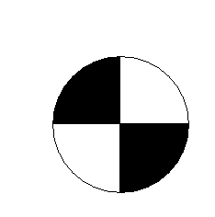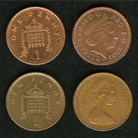
a
3cm
3cm
  - What total mass, M, of coins is required to get the structure to balance at this lever arm?
(NB do not forget to include the moment created by the small square of card)
  - Use the following information on the mass of standard coins to find a combination of coins that gets as close to M as possible
W20

Coin | Mass (grams)
£2 | 12
£1 | 9.5
50p | 8.0
20p | 5.0
10p | 6.5
5p | 3.25
2p | 7.12
1p | 3.56

  - Stick the coins inside the square to regain balance

Tying the Roof Down

- Are there any other ways to improve the visual appearance of the roof even further?

