Stadium Roof Design

Summary

National Curriculum Tie-In

Activities

- Design considerations of a stadium roof
- Emirates Stadium structural analysis
- Cantilever roof

Learning Goals and Objective

Upon completing of the activities, the student will have an enhanced understanding of the following laws and concepts of physics:

- Forces
The student will be able to balance forces the forces acting of
- Moments
Use the theory of moments to analyse and construct a simple cantilever roof structure

Design considerations of a stadium roof

For this class discussion divide the class into the three groups representing the Spectators, the Owners/Operators and the Participants

Spectators
- Shading from the sun
- Shelter from the wind and rain
- Unobstructed viewing
- Sense of Identity
- Safety
- Aesthetically pleasing
- Cool and well ventilated

Owners/Operators
- Flexible
- Easy to maintain
- Durable
- Good broadcasting facilities
- Energy Efficient
- Cost Effective

Participants
- Good quality of playing surface
- Good atmosphere
- Floodlighting
- Ventilation

Points for discussion

- Sun exposure
It is important to model the shadow cast from the roof onto the pitch and stands at different times of the day and year. The main stand of a stadium usually faces east, so that, for afternoon matches, the minimum amount of spectators will have to look into the sun.
Any sport played on a natural grass surfaces, e.g. Football and Rugby, will try to reduce the shading from sunlight on the pitch as this will have a detrimental effect on the grass quality. Completely enclosed stadia cannot, at present, have natural grass pitches but the following experiments have been undertaken;
  - Roll-in/Roll-out pitch at Toronto’s Skydome. The grass is maintained in the open air then slid into the stadium when needed.
  - Grass pitch which can be raised to roof level through the use of jacks, named “Turfdome” and invented in New York by Geiger Engineers, presently un-built.
  - Permanent translucent roof fitted with artificial light
  - Retractable roofs, allowing sunlight in whilst being able to enclose the entire space if needed.

- Wind and Air flow
Circular or elliptical shapes of roofs normally have a claming effect on the air inside the stadium. The comfortable air conditions inside the Don Valley Stadium in the UK are even suggested to enhance the performance of the athletes. However, roofs that are designed to have open gaps at the corners can be beneficial, particularly for grass pitches, as it aids drying out after rain and increases air movement over the grass, enhancing its quality.

- Flexibility and cost
The type of roof chosen for a stadium has a massive impact of the flexibility of that venue. To achieve financial viability a stadium needs to bring in revenue during off-season periods and on the days when matches aren’t played during the season. Most stadiums achieve this with a generous provision of conference facilities, Health Clubs and even hotels, such as the new development at Twickenham. However some stadiums, such as the Millennium stadium in Cardiff, have retractable roofs allowing it to function in all season and weathers, hosting a range of activities from conventions to opera and major cultural festivals.
Stadium Australia, the Olympic stadium for the 2000 games, was designed to have different phases. During the Olympics the stadium could accommodate 110,000 spectators by means of temporary upper tiers to the Northern and Southern stands. This was then removed after the Olympics, with the roof extended in modular fashion to cover the spectator areas at each end. The roof was also designed to allow for a 3rd phase incorporating two retractable sections creating a complete cover to the event arena should it be desired in later years. This type of approach to stadium roof design means that costs are incurred only as and when new sections of roofing are required and that the venue can change to meet future demands extending its design life.

- Design Life/Maintenance
The design life of different elements of the roof will vary from around 50 years for the load bearing structure to perhaps only a year for some of the finishes, depending on the type and quality. The elements, such as the roof covering and cladding, must be designed for easy replacement and an in depth maintenance strategy will need to be considered during the design stage.

- Environmentally Sustainable Development (ESD)
The visual impact that the stadium has on the surrounding area is extremely important to consider at the design stage. Stadiums are inward looking and quite often have tall, imposing “backs” that can be an eyesore at street level outside. Some stadium pitches are actually reduced below ground level to lower the height of the roof structure in order to blend in better. However a stadium that is designed to stand out and make a statement will have an elaborate extravagant roof structure that is hard to miss, such as Wembley.
The energy consumed by a stadium is one of the most important aspects to consider in the design stage. A stadium roof should aim to allow as much daylight as possible into the building, reducing the need for artificial lighting. However, especially during winter, flood lighting is essential to ensure that not only players and spectators have visibility but also so that TV cameras can still transmit the pictures to millions of additional spectators. To minimise the energy required, floodlights can be mounted on the roof structure which will evenly distribute the light around the stadium, this will also reduce the light pollution nearby houses may experience. In the Australia Stadium 2000 a daylight scoop was employed using the roof to reflect sun rays down into atriums reducing the amount of artificial light needed.
Considering the Environment during the design of sport venues is becoming a requirement. The London Olympics 2012 bid was secured due its strong commitments to be environmentally responsible and funding and planning is difficult to acquire if the designs do not consider sustainability.

- Roof Types
The form of structure selected for a stadium roof will have the largest impact on the cost, time to construction and obstruction to viewing.
The simplest of structures are Goal Post structures, which comprise of a post at either end of the stand and a single girder spanning the entire length between them that supports the roof. It cheap and used widely in the UK, but is only suitable for rectangular stadia as it cannot form a curve.
Cantilever structures are held down by securely fixing one end, leaving the other end to hand unsupported over the stands. This provides unobstructed viewing and can form circles or ellipses, such as the North Stand at Twickenham.
A space frame is constructed from interlocking struts in a geometrical pattern which are commonly steel tubes. It draws it strength from the triangular frames that make up the truss-like rigid structure. It’s lightweight, capable of spanning large distances with few supports, and can create curves to increase the visual impact. They are an expensive option but can be prefabricated in small chunks off site, ensuring the quality of workmanship and reducing the construction time.
All the primary forces in a tension structure are taken by members acting in tension alone, such as cables. The roof covering is often a polyester or glass fibre fabric which gives an airy, festive appearance to a stadium. They can be adapted to any stadium layout however require very sophisticated design as rain and snow can collect in ponds, overloading a concentrated area of fabric and can lead to failure. The 1972 Olympic Stadium for the Munich Olympics is a nice example of this type of structure.

- Material Selection
The materials selected for different parts of the roof will be measured against criteria based on required design life, technical aspects and aesthetics.
  - Roof Coverings
The requirements for a satisfactory roof covering include the need for the material to be lightweight, tough, water-tight, incombustible, aesthetically acceptable, cost-effective and durable. Opaque coverings such as steel or aluminium sheets are commonly used and are cheap and easy to fix. In some instances, where the roof structure is also the covering, lightweight concrete is used but it will become weathered and stained if not treated or finished. Translucent coverings are often rigid plastics, such as PVC or acrylic, which are waterproof, strong and can withstand large deformations without damage. Plastic fabrics can also be used as a non-rigid, transparent roof covering used for the roofing of the Olympic stadium refurbishment in Rome for the 1990 World Cup and can create dramatic shapes if used correctly.
The main problem faced with the roof covering is the collection of rain or snow in ponds on the roof which can overload the covering material and lead to failure.
  - Concrete
Concrete is a very versatile building material and is commonly-used for stadiums as it is cheap, fire-proof and can be cast in any shape. This makes it the only material capable of creating the seating profiles for a stadium but is rarely used for the roofs as it is heavy and unattractive once weathered.
  - Steel
Steel offers a slender and graceful solution for roofs as it is lighter and more aesthetically pleasing than concrete, so is the obvious choice for roof structures. Also, as the roof sits above the spectators, the required fire-proofing for safety is less, as long as the stadium can be evacuated within a defined time before structural failure or smoke suffocation occurs. This, coupled with the ability to be prefabricated off-site, makes steel a cost effective and sensible choice for the load bearing structure of a roof.

Emirates Stadium Structural Analysis

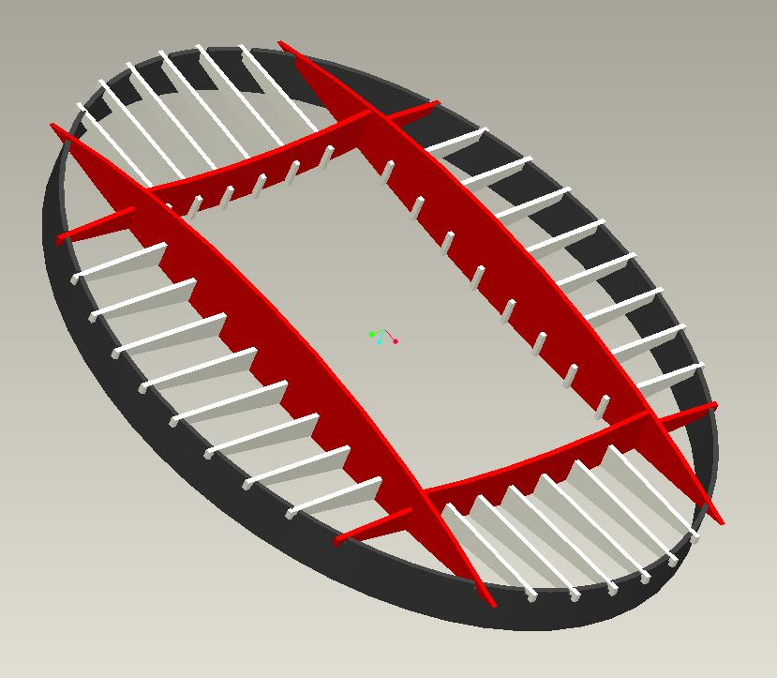
This activity is based on the Arsenal Football Emirates stadium, recently built in 2006. It focuses on the roof structure, with particular attention on the two largest steel girders that span almost the entire length of the stadium. By evaluating the forces one of these girders withstands a moment calculation can be made to determine the required cross-sectional area of the girder and hence the girder can be designed.

Cut-out Model

In order to understand the position and magnitude of the loads experienced by the main girders the following cut out model can be assembled.
To assemble,
- Locate the pieces marked with number 1.
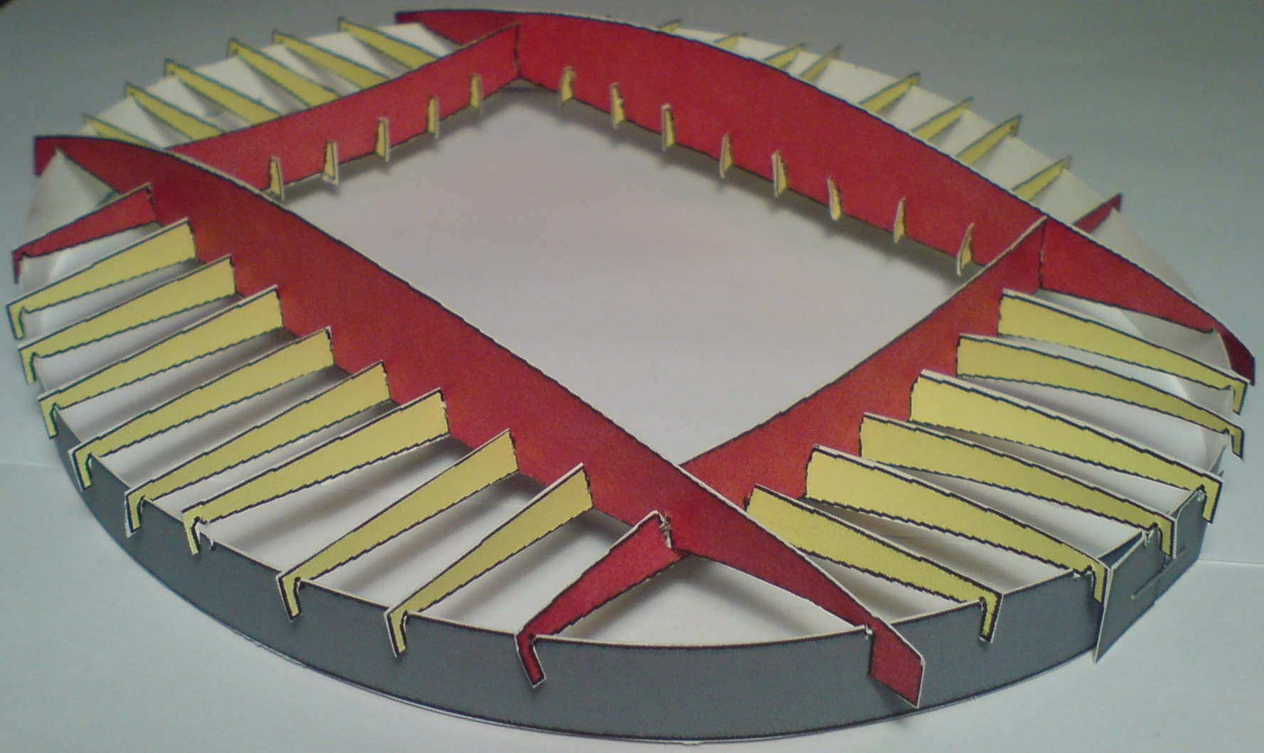
- Cut around the black line, leaving the triangular slots till last.
- In all but the smallest triangular slots, cut a small vertical slit following the black line, enabling the pieces to remain in position during assembly.
- Using the following pictures as a guide slot the pieces together.
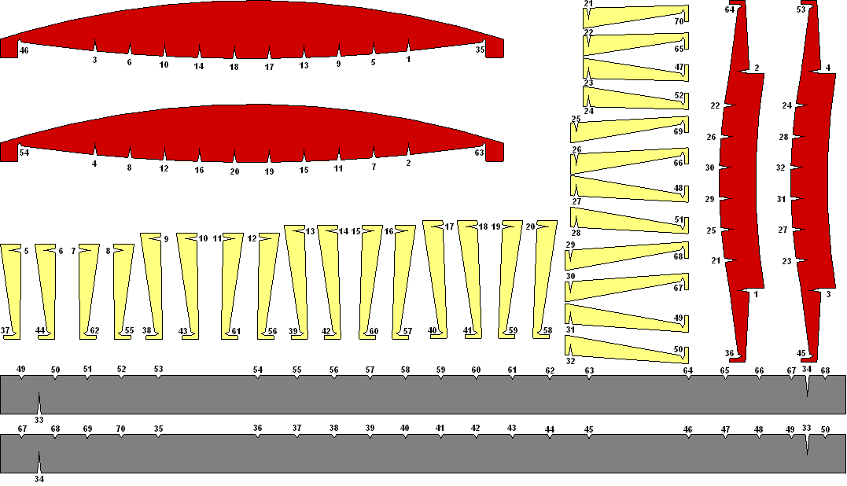
- The outer ring is assembled by slotting numbers 33 and 34 together and stapling the overlapping joint to fix the shape.
- As suggested by the numbering, to set the assembly inside the outer ring, start with an end of a primary girder and work round, slotting the other girders in place one after the other. You may need to go round the model twice as some may pop out while the outer ring changes shape.

Investigating the design of the Primary Girder

The two primary girder’s spans _____ each and supports the entire weight of the roof with just ____ kg of steel. However the structural engineering decisions behind it’s size and geometry are based on very simple calculations of force and moment balance and stability.

Background on types of load

Forces
Forces can cause the body on which they act to accelerate, rotate or deform. They are measured in Newtons which has the equivalent of kgms⁻², i.e. it takes 1 Newton to give a 1kg mass 1ms⁻² of acceleration. Forces in structures will cause them to deflect or rotate, and it is this deflection and rotation which needs to be minimised in order to prevent the structure failing.
The different types of forces that we will consider in this analysis of the Emirates stadium are
- Tension
- Compression
- Bending Moments

Tension forces are “pull forces”. These can be demonstrated with a 30cm plastic ruler by pulling either end. If you were able to apply enough tensile force to the ruler it would eventually break in half.
- What does the ruler do under tension?
When a tension force is applied to an object the object will try to get straighter, causing it to stretch. So any imperfections, eg bumps or kinks, will smoothen out while under tension.
- Discuss the effect of material type on the tensile strength of the ruler
What would happen if the ruler was made of polystyrene?
Conclude that as the material strength increases it can take more force so the tensile strength increases.
- Discuss the effect of cross-sectional area on the tensile strength of the ruler
What would happen if the ruler was only a quarter of its width?
Conclude that as the cross-sectional area decreases it can take less force so the tensile strength decreases.

So we know that the strength α Force
And strength α⁻¹ Cross-sectional area
Therefore the strength must be a measure of how much pressure the material can withstand before breaking since,
Pressure = Force
Area
This material property is called the yield stress σ_{y}, and is unique and fixed for a given material.
To calculate the tensile force a particular component can withstand use;
Force = σ_{y} x Cross-Sectional Area

Compressive forces are “pushing forces”. These can be demonstrated with the ruler by pushing each end, making your hands closer together.
- What does the ruler do when you “compress it”?
Conclude that it bends or deforms out of the plane in which the forces are acting.
This is a key behaviour of things in compression called buckling. This behaviour is not desired in structural members as it can easily lead to failure and can sometime happen very quickly without much notice.
- What happens if you try to compress a shorter or a longer ruler?
Conclude that it is easier to “buckle” a long ruler than it is a shorter one
- What happens if you take a straw and a pencil of the same length and try to compress them?
These both have similar diameters but the key difference is that the cross-sectional area of a pencil is much greater than the straw which is a very thin circular tube.
Conclude that it is easier to buckle something with less cross-sectional area.

The moment of a force is a measure of its tendency to cause a body to rotate. If this rotation is resisted the body will bend, so is called a “bending moment”. By putting the ruler on the edge of a table and pushing down on the free end the ruler will pivot about the edge of the table and rotate. If you place your hand on top of the ruler on the table and re apply the force, the bending moment is resisted and will cause the ruler to bend.
- What two elements do you need, to be able to apply a moment to a point in the ruler
A moment comprises of a force applied a perpendicular distance away from the centre of the moment. It can be calculated from;
Moment = Force x perpendicular distance between line of action and centre of moment
M = F x d
- Lay the ruler flat on the table, how else can you cause it to rotate freely?
With the ruler horizontal consider applying an upwards force with one hand and a downwards force with the other at either end of the ruler to make it rotate.
- If a friend now holds the centre of the ruler down and the forces are applied again what happens?
This resistance to the rotation of the moment again causes the ruler to bend and deform.
- How would you calculate the moment now acting on the beam
This type of moment is called a couple, as it is a pair of equal forces acting the same distance away from the pivot. As the two forces will create a moment in the same direction in the centre, and if they are a distance d apart, using the equation above we get
Moment = F₁ x d/2 + F₂ x d/2
As F₁ = F₂ = F, this gives
Couple = F x d

Loading in the Roof

The girder roof structure needs to support the weight of the roof covering, light and sound fixtures and elemental loading from wind, rain and snow. The load is first taken by the short tertiary girders which then transfer their load to the secondary girders or straight to the primary girders depending on which it is connected to. The secondary girders then transfer their load to the primary girders which transfer this load to the roof tripods at the edge of the stadium.
To calculate the loading on the primary girder
- Measure the lengths of the tertiary girders
(NB : the roof is symmetrical in two planes so out of the 32 yellow tertiary girders, only 8 need to be measured)
- Calculate the equivalent load from
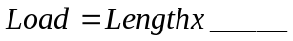
Where ______ is the load of the roof covering, light and sound fixtures per unit length of girder
- Each primary beam takes half the total load of the roof so cover up half of the structure to focus which tertiary beams are significant to one of the primary beams
- Calculate the force exerted by the secondary beam on the primary beam by summing up the forces of the three relevant tertiary beams that are connected to the secondary beam

Free body diagram of Primary Beam

To assess the forces acting on the Primary beam it will be treated as a free-body.

The following assessment of the primary girder can be undertaken to assess the tension and compression force at the centre
- Complete the forces in the 2-D representation of the beam
By representing the beam as a 2D object the forces from the tertiary and secondary beams can be represented as “Point Loads”.
- Calculate the reaction force, R, at each end of the beam
Sum up the forces from the other beams and divide in half.

The Primary beam is carrying downward loads from the tertiary and secondary beams.
At either end the beam is supported by tripods, so it will transfer half of the total downwards to each tripod as it is symmetrical. This must be balanced with a reacting force upwards from the tripods acting on the girder itself, according to Newton’s third law of equal and opposite forces.

- Cut the beam in half to investigate the moment acting in the middle of the beam which will dictate the design
First discuss where the girder will be experiencing the greatest loading. The middle is an obvious choice as it is furthest away from the supports. So we have found the point of interest.
The next step is to “cut” the structure at this point and investigate the type and magnitude of the load at this point.

By cutting the structure we have destroyed the forces within the structure, so we need to replace them by considering it as a free-body. Looking at the equilibrium of the vertical forces shows that they still balance, so we have not destroyed a vertical force. The next step is to investigate the moment balance at this point. The anti-clockwise moment comes from the reaction force R, and the clockwise moments come from the downwards loading from the other girders. The clockwise and anti-clockwise moments do not balance, so there must be _____ of clockwise moment at the cut to balance and keep the girder in equilibrium.

This is the moment acting inside the structure, capable of “sticking” the structure back together.

- Separate the moment into a tension and compression force acting at the top and bottom of the cross section

Having found the internal moment acting at this point in the structure, investigation into how the girder will carry this moment takes place. We already know that the girder will be made out of long steel tubes at the top and bottom which can only carry a tension or compression force. So the moment must take the form of a couple formed by this tension and compression force that act at the top and bottom of the cross-section. The tension and compression force must be equal to each other and can be calculated from
Couple = Force x Distance between forces
The distance between the forces can be measured and scaled up from the cut-out model so that
Force = Moment
Width of girder in the middle

To decide whether the tension force acts at the top or bottom of the cross-section, consider the turning effect of the two different scenarios. The tension force on the bottom and the compression on the top will give a clockwise moment, and so is the correct choice.

- Design the tension Girder
The bottom girder is in tension, which means it is being stretched. The limit of the amount of stretching you can do is related to the material and geometrical properties. For example, a thin elastic band will break with less force than a thicker one as the thicker one has a greater cross-sectional area. However, try and apply a similar sort of tensile force to a plastic ruler and you wont even be able to get it to stretch a little as it is a different material from rubber.
We already know that the girder will be made out of steel, so we need to calculate the cross-sectional area required to maintain the tensile force without breaking.
Steel can withstand a pressure of 325N/mm² before breaking, so using
Pressure = Force
Area
The Cross-sectional area (in mm) required = Tensile Force
325

If circular hollow tubes with a thickness of 40mm are used the required radius (in mm) can be calculated from
Cross-sectional area = 2xπxradiusxthickness
So Radius = Cross-sectional area
2x π x 40

- Design the compression Girder
The compression girder will also need to have this cross-sectional area in order to withstand the force without breaking. However, the main problem with things in compression, especially when they are thin and long, is buckling. When you apply a pushing force to each ends of a long ruler it deflects in a different direction to the force you are applying. The Top compression girder of the primary beam will behave in exactly the same way. So to prevent this out of plane deformation, which causes the girder to be unsafe and unstable, the tension girder is split in two to make a triangle providing lateral bracing for the compressive girder. Now when the compressive force is applied to the top, the out of plane movement of the top steel tube will be resisted by the bracing.

Cantilever Roof Design experiment

The aim of this exercise is for each student to create a design for a cantilever roof. They will then investigate ways in which the overhanging roof can be supported using the principle of moments.

Dimensions

Strong, thick card should be cut into A5 pieces (148mm x 210mm). The “mast” should be 2cm thick and the balancing foot requires 3cm to ensure adequate stability while balancing. The cantilever roof itself will be 12cm and at the very most 4cm thick, this is to ensure that the spectators in the sloped stands retain a good sight line.

4cm
3cm
2cm
1cm
7cm
12cm
21cm
14.8cm
STANDS
Cantilever Roof
Counter Weight Roof
Fold

- Transfer the measurements to the A5 card
- Cut out the grey areas as marked on the diagram, and cut and fold the balancing foot
- Calculate the depth of the counter weight required to balance the cantilever roof
The weight of the cantilever roof will create a moment about the mast. If this is not balanced by an opposing force on the other side the roof would topple over. So, a counter weight is used to balance the weight of the roof. The dimensions of the cantilever roof are fixed at 5cm x 12cm and the counter weight has a fixed width of 7cm. What is the required depth of the counter weight to balance the moment from the cantilever roof.

The mass of card is usually specified as 500gsm, which is 500grams per square metre, or 0.05g/ cm². If sensitive enough scales are available the students could weigh a 1cm x 1cm square to find the cards’ mass per cm². With this value the force exerted, ie the weight, can be calculated from; We know that in order for the roof to balance the moment that these two forces have about the mast must be equal.

Weight = mass per cm² x gravity x Area
Moment = Force x Perpendicular distance from pivot

Weight of Cantilever Roof = 0.05 x 9.8 x 4 x 12 = 23.52N
Weight of Counter Weight = 0.05 x 9.8 x 7 x y = 3.43y N

Clockwise Cantilever Roof Moment = 23.52 x (12/2 +1) = 164.64Ncm
Anti-Clockwise Counter Weight Moment = 3.43 x (7/2 + 1) = 15.435y Ncm
 | Area | Weight | Lever Arm | Moment | Clock/Anti
Roof | 4 x 12  = 48 cm² | 0.08 x 9.8 x 48 = 37.6 N | 12/2 + 1  = 7cm | 37.6 x 7  =263.2 Ncm | Clock
Counterweight | 7 x y  = 7y cm² | 0.08 x 9.8 x 7y = 5.49y N | 7/2 + 1  = 4.5cm | 5.49y x 4.5  = 24.7y Ncm | Anti

Equating the clockwise moment from the roof with the anti-clockwise moment from the counter weight gives

24.7y = 263.2
y = 263.224.7 = 10.7cm ≈ 11cm
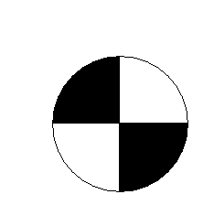
y

- Mark out y on the card and cut away the excess card. The roof should now balance

- As the current design for the cantilever roof is not very aesthetically pleasing the students can cut out their own design for a cantilever roof from the 4cm x 12cm rectangle.

- With this new design it is essential to know how much material has been used as this will have a direct impact on the cost of the structure.

- Reduce the depth of the counter balance, ensuring that it remains a rectangle, until the structure balances again.

- In order to perform the same moment balance to calculate the area of the new roof structure we need to know where it’s centre of gravity is.

Trace the shape of the new roof onto the piece of card that was cut away at the start. Punch a hole near an end of it and hand the shape with a drawing pin to a notice board. Ensure that the shape is hanging freely and, with a ruler, draw a vertical line on the roof from the drawing pin downwards. Punch a second hole in a different part of the roof and repeat to find a point where the two lines cross. This is the centre of gravity of the shape.
Any other method to find the centre of gravity may be used.
Now measure the distance from the mast to the centre of gravity, d, which will be the lever arm for the weight of the cantilever roof in the following calculation.
a

- We can now solve the same moment balance equation as before but this time in order to find the unknown area, A, of the roof structure

Measure the counter weights’ Depth, D.

Weight of Counter Weight = 0.05 x 9.8 x W x D = 0.49WD N

Weight of Cantilever Roof = 0.05 x 9.8 x A = 0.49A N

Anti-Clockwise Counter Weight Moment = 0.49WD x (W/2 + 1)
Clockwise Cantilever Roof Moment = 0.49A x (a + 1)
Equating these to Moments gives an expression for A as follows
A = WD (W/2 + 1) / (d +1)

This area can be checked by using a piece of graph or square paper, tracing the shape and counting the squares.

- At the moment we have cantilever roof with a massive counter weight, which is not very aesthetically pleasing. To reduce the size of the counter weight, coins can be stuck next to the mast as shown. Again a moment balancing calculation will reveal how many coins are needed in order to make the roof balance.

A £2 coin has the largest diameter of 28.4mm, so the counter weight should be reduced to a 30mm square in the top right hand corner, as shown on the diagram. When the coins are added they should be placed in the middle of this square to ensure that the lever arm of the combined weight is 2.5cm.

The required mass, M, of the coins can now be calculated from another moment balance.

Weight of Cantilever Roof = 0.05 x 9.8 x A = 0.49A N
Weight of remaining Counter weight = 0.05 x 9.8 x 3 x 3 = 4.41N
Weight of Coins = 9.8 x M = 9.8M N

Clockwise Cantilever Roof Moment = 0.49A x (d + 1)
Anti-Clockwise Remaining Counter Weight Moment = 4.41 x 2.5 = 11.025 Ncm
Anti-Clockwise Coin Moment = 9.8M x 2.5 = 24.5M Ncm

Again, setting the Clockwise moments equal to the anti-clockwise to ensure the roof balances gives;

0.49A x (d + 1) = 11.025 + 24.5M
re-arranging gives
M = (0.49A x (d + 1) – 11.025) / 24.5

Using the following estimates for the mass of various coins, find a combination of coins that gets as close to M as possible and stick these onto the remaining counter weight using sticky tape.

Coin | Mass (grams)
£2 | 12
£1 | 9.5
50p | 8.0
20p | 5.0
10p | 6.5
5p | 3.25
2p | 7.12
1p | 3.56

If the cantilever doesn’t quite balance with the coins available, how can it be improved?
By moving the coins closer or further away from the mast, will decrease or increase the lever arm of the coins. This will change the moment and so a balance point should be able to be found.

- The coins have improved the visual appearance of the roof structure but how could it be improved even further?
The counter weight needs to maintain the same lever arm distance, but it can move vertically up and down and not affect the balance of the roof. So if the counter weight is tied down to the earth it will be put out of sight so that is doesn’t compromise the aesthetic appeal of the cantilever.
To demonstrate this, remove the coins and punch a hole in the centre of the 30mm square. Thread a piece of string through this hole and hang the same weight in coins on the end of the string to re-establish equilibrium.
Most cantilever roofs for stadiums are secured in this way.

